

Corporate Order Importer Step-by-Step Guide
Before Getting Started:
Ensure there is already a contact built for the gift giver with an up-to-date email address and credit card on file. | ☐
Acquire all gift receiver shipping information and products within each corresponding order. | ☐
Create a new Order Type, such as "Corporate Import," to process Corporate Orders through and better track sales. | ☐
If applicable, create a promo to discount appropriate wines for the orders. | ☐
Jhb
Building the Processing Tool:
1. Navigate to the Corporate Order Importer Tool (Settings>Import/Export>Corp. Order Importer) and select the green "Import Corporate Orders" button.
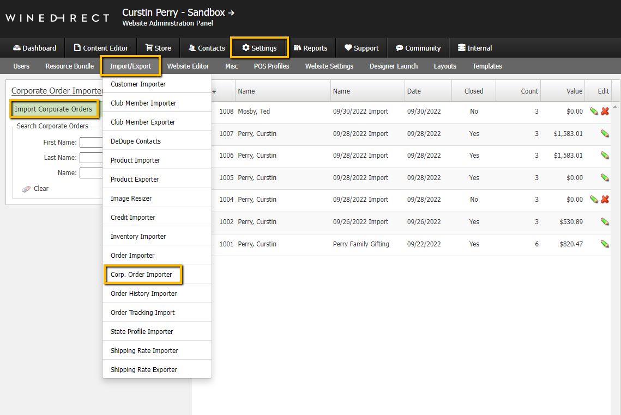

2. Fill out the contents of the "General" tab within the processing tool.
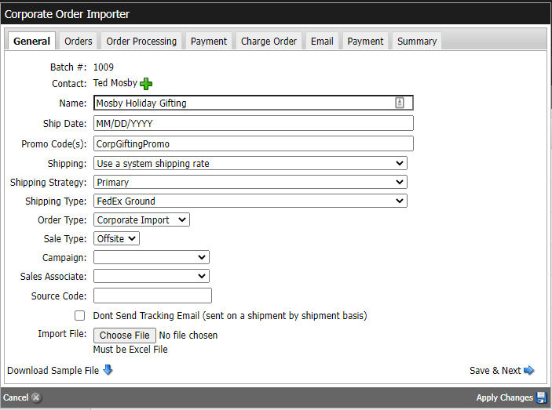
- Add a billing contact.
- Name could be the company who is gifting, such as "ABC Inc. Holiday Gifting," or the family that is gifting, such as "LastName Gifting," etc.
- The "Ship Date" will be applied to all orders. Disregard if orders will be picked up.
- If applicable, add the promo code to apply to orders.
- "Shipping," "Shipping Strategy," and "Shipping Type" are required fields. Like the club processing tool, you can choose to use a system shipping rate or a flat fee. If orders will be picked up this setting can be overridden in the import file (this will be referenced later in the step-by-step guide).
- Adjust the "Order Type" accordingly.
- "Sale Type" refers to whether the sale was generated onsite or offsite, this adjusts taxes accordingly.
- If this sale needs to be associated with a phone campaign, you can select the appropriate campaign.
- If applicable, choose the Sales Associate for the orders.
- The "Source Code" is a free form note field that is not customer facing in which you can type internal notes or details for the orders.
- By default, shipment tracking emails will be sent out on an order-by-order basis. Check the "Don't Send Tracking Email" box if you would like to turn this off.
- Select the "Download Sample File" button to begin building the gift orders.
- At this point, you can press "Apply Changes" to save your processing tool.

Building the Gift Orders:
1. Open the "Sample File" and begin inputting gift receiver shipping information for each order.
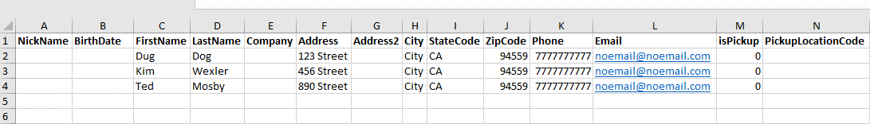
- The only mandatory fields for recipient information are: First Name, Last Name, Address, City, Zip Code, and Phone Number. These fields cannot exceed 50 characters, or the order import will fail.
- The recipient email address will not receive tracking information or order confirmation emails, only the billing customer will receive these emails.
- If any orders will be picked up rather than shipped, put a "1" to indicate "yes" in the "isPickup" column. For pick up orders, you will also need to include the Pickup Location Code in column "PickupLocationCode." This can be found by going to Settings>Misc>Pickup Locations.
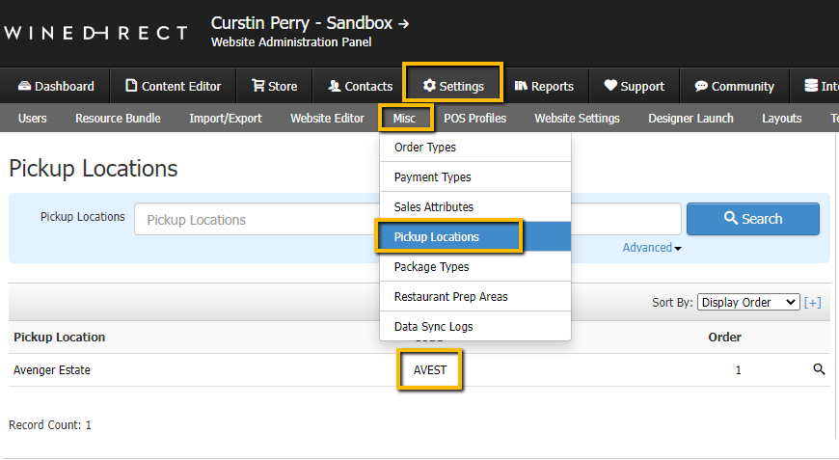
- "Order Notes" are customer facing instructions or notes.
- If desired, individual gift messages can be included in the orders.
2. Begin inputting products, quantity, and pricing for each order.
- The "SKU" must match the SKU set up within WineDirect exactly.
- The "SKU Qty" cannot be zero. If a product is not needed in a particular order, simply leave that SKU out of the order.
- Ensure the "SKU Price" matches the retail price set up within WineDirect exactly. If the price differs, then the system will override the retail price. Promos cannot be applied to an overridden price within the Corporate Order Importer Tool.
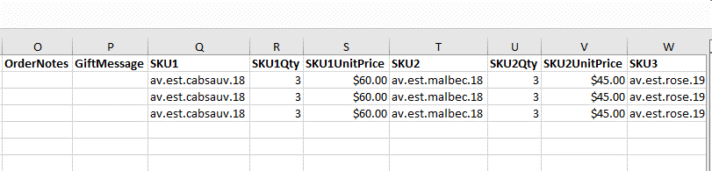
3. When finished, save your Excel file.
- Ensure you do not edit the column headers prior to saving the file.
- When saving, do not change the Excel file's format as the system only accepts certain Excel files.
- Save the file to an accessible folder or create a new folder titled "Corporate Order Imports."
4. Import the orders into the Corporate Order Importer Tool.
- When ready, choose the correct file to import and press "Save and Next."
- If any changes need to be made to an order that has already been imported, do not reimport the file into the processing tool as this will duplicate the order(s). Changes to an order can be made within the "Orders" tab of the processing tool.
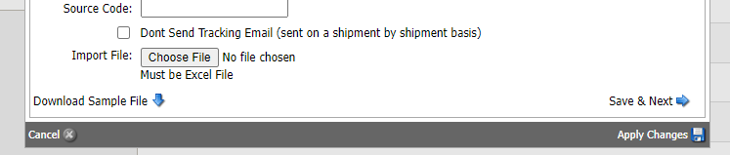
Verifying and Editing Gift Orders:
1. Double check orders as needed.
- If desired, you can select the magnifying glass next to any recipient’s name to double check the contents of their order, that a promo applied correctly, and that the shipping address is accurate.
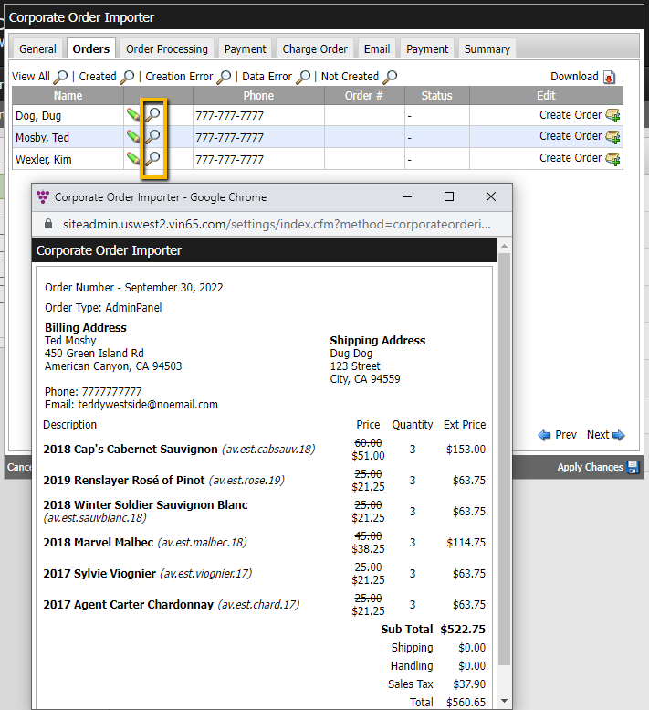

2. Make edits if necessary.
- If an order needs to be adjusted, select the green pencil next to the recipient's name to open an edit order window.
- Within this window you can adjust the shipping information, specific order details, and the contents and quantity of the order.
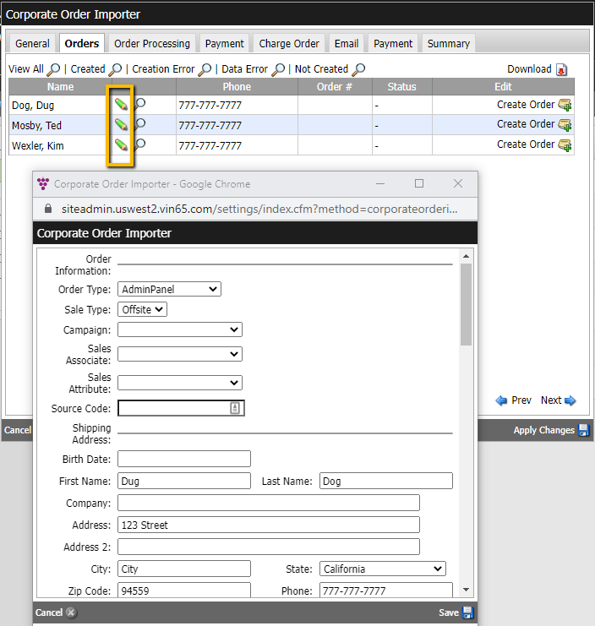
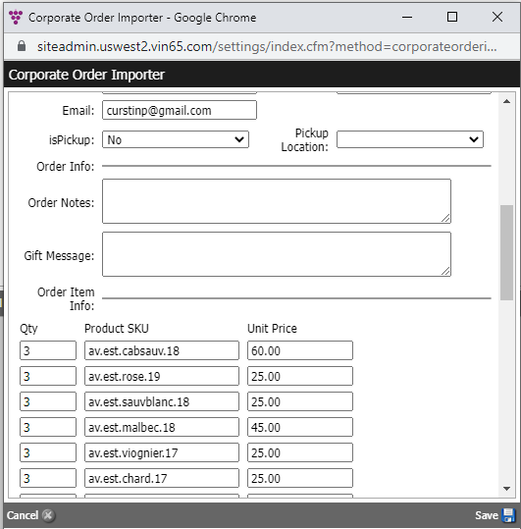

Processing the Orders:
1. Once the orders are ready, select the "Order Processing" tab.
- Similar to the club processing tool, you can create orders in bulk by selecting the "Start" button.
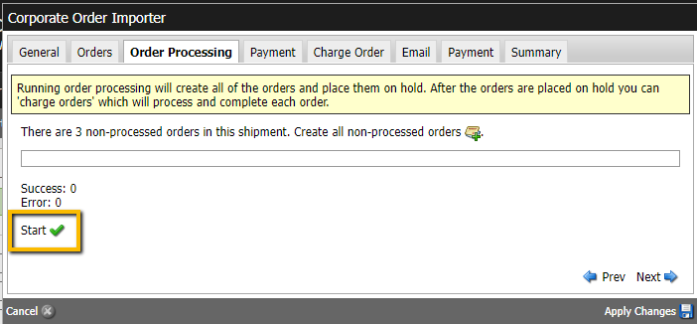
- Unlike the club processing tool, once the orders are created, they are not complete as payment for the orders has not been processed yet.
2. Adding payment.
- Once the orders have been created, select the "Payment" tab.
- Within this window, you can determine the form of payment for the orders.
- The only forms of payment that can be used within the Corporate Order Importer Tool are credit card and check.
- You can select a credit card on file for the billing customer, create a new credit card to be saved on file for the billing customer, or input a one-time use credit card.
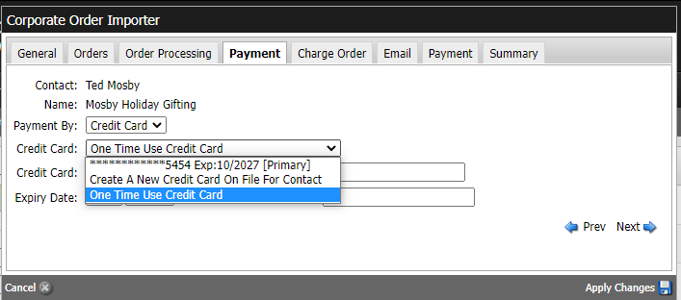
3. Charging the orders.
- Once a payment method has been added, select the "Charge Order" tab.
- Within this window, you'll see the total charge for all imported gift orders.
- To process one payment for all gift orders, select the credit card icon with the green plus symbol.
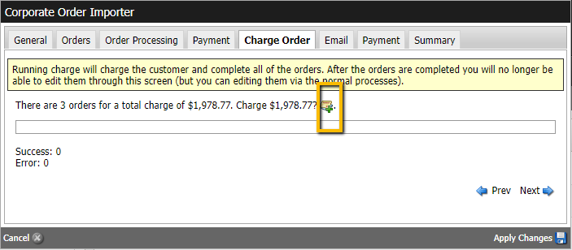

4. Send a confirmation email to the billing customer.
- Once the payment has been processed, select the "Email" tab.
- Within this window, you can download an Excel file with the charge summary (this will look similar to the imported file).
- Additionally, you can preview and send the order confirmation email to the billing customer.
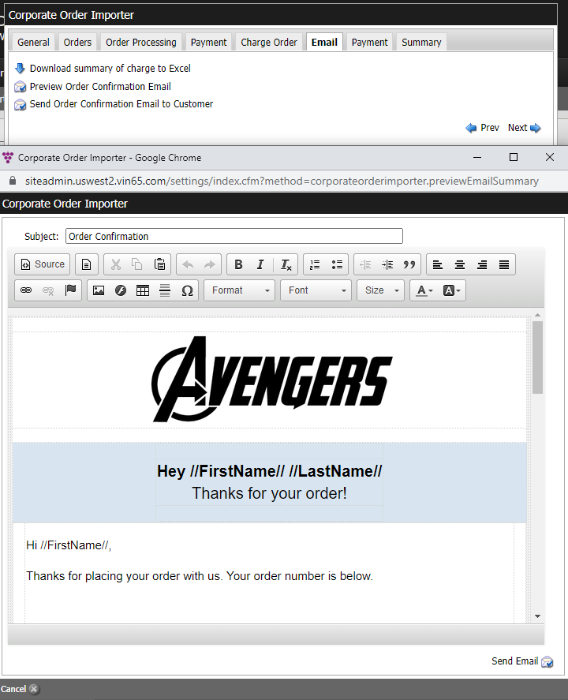

- The order confirmation email will include all gift orders as a single line item with the order number, recipient's name, shipping address, and the charges associated with that order.
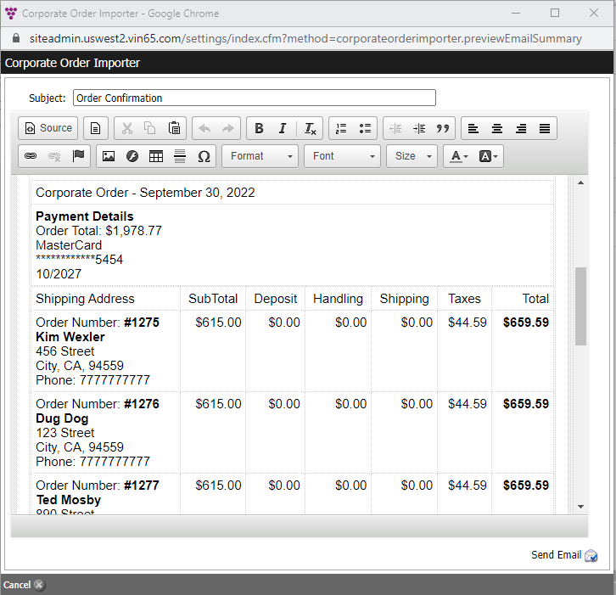

Important Things to Note:
1. Orders created and processed through the Corporate Order Importer Tool will always be associated with the billing customer's contact.
- Additionally, adding receiving contact information within the Corporate Order Importer Tool will not automatically create new contacts within the system.
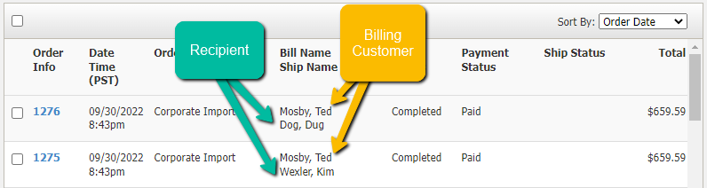
2. The Corporate Order Importer Tool cannot be used to purchase and distribute gift cards in bulk. Instead, use the Order Importer Tool (Settings>Import/Export>Order Importer).
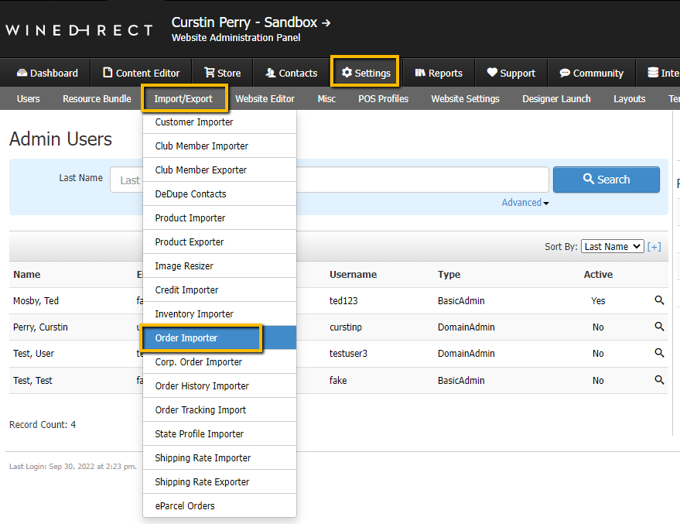
3. If orders have been created but no payment has been processed, they will live under "Status: Hold" and "Payment: Pending" within the order search window.
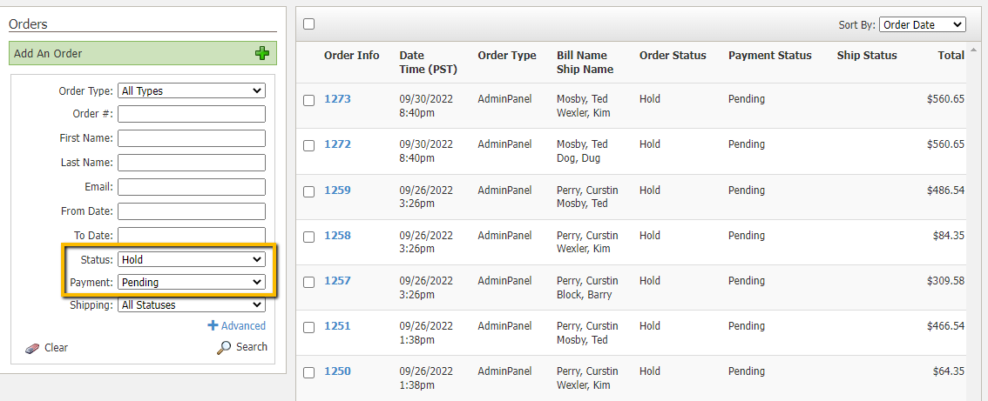

We hope you found this helpful!
For additional training needs, reach out to us at training@winedirect.com or visit the WineDirect Academy.

